**Introduction to the Dataset:**

The dataset used in this analysis contains essential information about companies, their financial performance, and details about the directors who serve on their boards. This data has been collected for the purpose of gaining insights into the composition of company boards, identifying trends, and understanding the characteristics of directors.

**Dataset Summary:**

* Company_Name: Name of the company.
* Russell_3000: A binary indicator (1 or 0) showing whether the company falls under the Russell 3000 list (1 for yes, 0 for no).
* SP_500: A binary indicator (1 or 0) showing whether the company falls under the S&P 500 list (1 for yes, 0 for no).
* FY_Data: FY_1 represents the latest year, FY_2 indicates the year immediately prior to FY_1, and FY_3 indicates the year prior to FY_2.
* Revenue: Represents the revenue generated by the company.
* Industry_Sector: Indicates the industry sector to which the company belongs.
* Director_ID: A unique code representing each director.
* Gender: Represents the gender of the director (M for Male, F for Female).
* CEO: Indicates whether a director is the CEO (1 for CEO, other values for non-CEO).
* Age: Represents the age of the director.
* Board_joining_date: The date on which the director joined the board.
* Resignation_date: The date on which the director resigned from the board.
* Board_Membership: Describes the position of the director on the board.
* Retirement_Age_Directors_Years: The retirement age of directors in years.
* Analyst_Note: Notes captured by analysts, if any.

**Purpose of Analysis:**

The primary goal of this analysis is to explore and understand the relationships and patterns within the dataset to answer key questions related to directors, their roles, and the financial status of the companies. This analysis aims to provide valuable insights into corporate governance and financial performance.

**Key Questions to Be Addressed:**

**What is the total revenue for each Industry Sector, and how do they compare?**

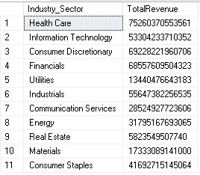

Query used for analysing above

SELECT [Industry_Sector], SUM(Revenue) AS TotalRevenue

FROM [ceo_analysis].[dbo].[Data_Pjt]

GROUP BY [Industry_Sector]

**How many directors are male, and how many are female?**

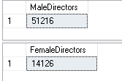

Query used for analysing above

-- Count the number of Male Directors

SELECT COUNT(*) AS MaleDirectors

FROM [ceo_analysis].[dbo].[Data_Pjt]

WHERE Gender = 'M';

-- Count the number of Female Directors

SELECT COUNT(*) AS FemaleDirectors

FROM [ceo_analysis].[dbo].[Data_Pjt]

WHERE Gender = 'F';

**How many female directors are CEOs and are over 50 years of age?**

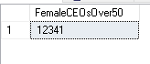

Query used for analysing above

SELECT COUNT(*) AS FemaleCEOsOver50

FROM Data_Pjt

WHERE Gender = 'F' AND Age > 50;

**What is the total revenue per Industry Sector for directors who have recorded Retirement_Age_Directors_Years?**

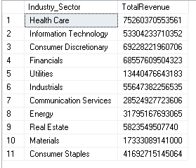

Query used for analysing above

SELECT Industry_Sector, SUM(Revenue) AS TotalRevenue

FROM Data_Pjt

WHERE Retirement_Age_Directors_Years IS NOT NULL

GROUP BY Industry_Sector;

**How many directors with recorded Retirement_Age_Directors_Years are over the age of 60?**



Query used for analysing above

SELECT COUNT(*) AS DirectorsOver60

FROM Data_Pjt

WHERE Retirement_Age_Directors_Years IS NOT NULL AND Age > 60;

**How many directors are recorded as having "Member" or "Chair" board membership, with Resignation_date recorded and Retirement_Age_Directors_Years recorded?**



Query used for analysing above

SELECT COUNT(*) AS DirectorsWithCriteria

FROM Data_Pjt

WHERE Board_Membership IN ('Member', 'Chair')

AND Resignation_date IS NOT NULL

AND Retirement_Age_Directors_Years IS NOT NULL;

**What is the total revenue per Industry Sector for directors with recorded Retirement_Age_Directors_Years who have served as "Chair"?**

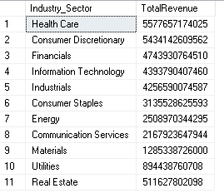

Query used for analysing above

SELECT Industry_Sector, SUM(Revenue) AS TotalRevenue

FROM Data_Pjt

WHERE Board_Membership = 'Chair'

AND Retirement_Age_Directors_Years IS NOT NULL

GROUP BY Industry_Sector

ORDER BY TotalRevenue DESC;

**What is the total revenue per Industry Sector for directors with Retirement_Age_Directors_Years recorded, who have served as "Chair," have a Resignation_date recorded, and were appointed to the board after 01-01-2015?**

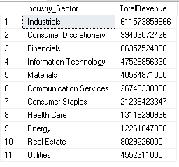

Query used for analysing above

SELECT Industry_Sector, SUM(Revenue) AS TotalRevenue

FROM Data_Pjt

WHERE Board_Membership = 'Chair'

AND Retirement_Age_Directors_Years IS NOT NULL

AND Resignation_date IS NOT NULL

AND Board_joining_date >= '2015-01-01'

GROUP BY Industry_Sector

ORDER BY TotalRevenue DESC;

**How many directors have Retirement_Age_Directors_Years recorded, have served as "Member," have a Resignation_date recorded, and were appointed to the board before 01-01-2010?**



Query used for analysing above

SELECT COUNT(*) AS DirectorsCount

FROM Data_Pjt

WHERE Board_Membership = 'Member'

AND Retirement_Age_Directors_Years IS NOT NULL

AND Resignation_date IS NOT NULL

AND Board_joining_date < '2010-01-01';

**What is the average revenue per Industry Sector for directors who joined the board before 01-01-2010, have a Board_Membership of "Chair" or "Member," have a Resignation_date recorded, and have Retirement_Age_Directors_Years recorded?**

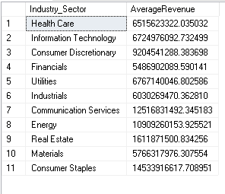

Query used for analysing above

SELECT Industry_Sector, AVG(Revenue) AS AverageRevenue

FROM Data_Pjt

WHERE Board_Membership IN ('Chair', 'Member')

AND Board_joining_date < '2010-01-01'

AND Resignation_date IS NOT NULL

AND Retirement_Age_Directors_Years IS NOT NULL

GROUP BY Industry_Sector;

**Queries used for Dashboard Visualization**

|  |
| --- |
| **Find out Male vs Female Director share in different Industry_Sectors and Revenue Category** |
| **Revenue Catrgory -** |
| $100M to < $300M |
| $300M to < $1B |
| Below $100M |
| 20 B and Above |
| $3B to < $10B |
| $10B to < $20B |

SELECT

Industry_Sector,

CASE

WHEN Revenue >= 100000000 AND Revenue < 300000000 THEN '$100M to < $300M'

WHEN Revenue >= 300000000 AND Revenue < 1000000000 THEN '$300M to < $1B'

WHEN Revenue < 100000000 THEN 'Below $100M'

WHEN Revenue >= 20000000000 THEN '20B and Above'

WHEN Revenue >= 3000000000 AND Revenue < 10000000000 THEN '$3B to < $10B'

WHEN Revenue >= 10000000000 AND Revenue < 20000000000 THEN '$10B to < $20B'

END AS Revenue,

SUM(CASE WHEN Gender = 'M' THEN 1 ELSE 0 END) AS MaleDirectors,

SUM(CASE WHEN Gender = 'F' THEN 1 ELSE 0 END) AS FemaleDirectors

FROM Data_Pjt

GROUP BY Industry_Sector, Revenue;

|  |  |
| --- | --- |
|  | **% of Directors in mentioned Age Category** |
|  | 40 Years or Below |
|  | 41 to 60 Years |
|  | 61 to 72 Years |
|  | Above 72 Years |

SELECT

Age,

(COUNT(*) * 100.0 / (SELECT COUNT(*) FROM Data_Pjt)) AS Percentage

FROM (

SELECT

CASE

WHEN Age <= 40 THEN '40 Years or Below'

WHEN Age >= 41 AND Age <= 60 THEN '41 to 60 Years'

WHEN Age >= 61 AND Age <= 72 THEN '61 to 72 Years'

ELSE 'Above 72 Years'

END AS Age

FROM Data_Pjt

) AS Age

GROUP BY Age;

**% of Companies disclosing Retirement age of Directors**

SELECT

SUM(CASE WHEN [Retirement_Age_Directors_Years] IS NULL OR [Retirement_Age_Directors_Years] = '' THEN 1 ELSE 0 END) AS NotDisclosed,

SUM(CASE WHEN [Retirement_Age_Directors_Years] IS NOT NULL AND [Retirement_Age_Directors_Years] <> '' THEN 1 ELSE 0 END) AS Disclosed,

COUNT(*) AS TotalCompanies

FROM [ceo_analysis].[dbo].[Data_Pjt];

**To see the dashboard Please Open other PDF!**